Created by Simranjeet Kaur Mann

EXAMPLE EXTRACTS OF MY LPC NOTES

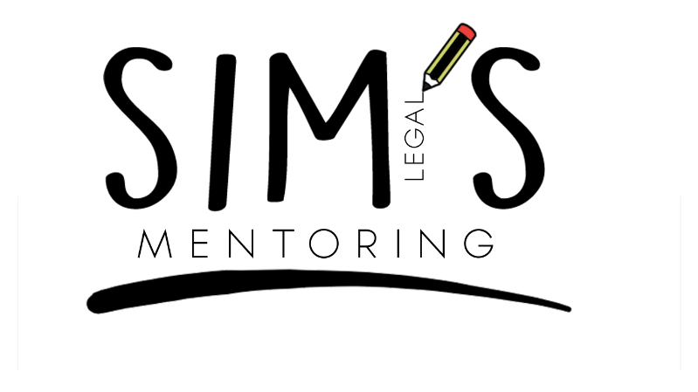

Hover over the individual site names to directly access my respective social media sites!

simranjeetkmann

Simranjeet Kaur Mann

Simranjeet Kaur Mann

**EXAMPLE 1 – BUSINESS LAW & PRACTICE**

**APPROACH TO AN EXAM QUESTION ON PARTNERSHIPS**

|  |  |
| --- | --- |
| **1** | **Is there a partnership?** |
| **2** | **Who are the partners? Are they *still* partners?** |
| **3** | **What type of partnership is it?**   * Fixed / At will? * GP / LP / LLP? |
| **4** | **What are the relevant terms?**   * Express by oral/written agreement – **s.19 PA 1890** * Inferred from conduct? * Implied by **PA 1890, LPA 1907, LLPA 2000** |
| **5** | **Apply to facts** |
| **6** | **Conclude** |
| **Watch out for** | |
| * **The time frame** – is there a gap? What could have happened in between? * **Profit** – be careful, have they been deliberately vague? Is it interest? An agreed payment? Consultancy fee? * **Do you need more information?** Ask questions! * **Restating statute terms?** Clarity, contractual remedy. * **What will happen to the partnership on dissolution? On death of a partner?** Try and think of questions that will be asked by the partner in this scenario… * A partnership – either an express agreement which a sol needs to be able to ascertain the terms of and advise on, or an implied agreement by conduct/ PA 1890 which need to be able to advise on. * Acting as agent? Do they have a share of the profits? | |

**EXAMPLE 2 – INTELLECTUAL PROPERTY**

Structure of a Registered Design Right

* 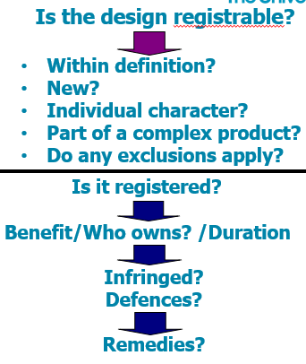Structure comes in two parts
* First part above the black line would be the points to consider and order to consider them if you are asked about the registrability of the design
* Second part below the black line would be followed if you are asked a question about infringement. Need to consider first whether you have a registered right. On an infringement question, may be considering whether design is registerable as a possible defence. An infringer will try to first attack the validity of the right, so this would be the appropriate place to consider whether design is registerable. Then go on to remedies after the defence section

**Registrability Question: (first half of structure)**

* Novelty – s1B (2) RDA
* S1b(5)(6) 🡪 12 month grace period allowing designer to disclose their sign within 12 months prior to registration. This is how RDR is different to patents.
* Individual character – defined in s1B(3) RDA
* Complex product – defined in s1(3) RDA
* S1B(8) – complex part incorporated into complex product (wing mirror)
* Exclusions – s1C

**Infringement Question: (second half of structure)**

* Consider what is actually registered and whether it is actually in the registration period
* If not, could it still be registered – 12 month grace period might be relevant here. If more than 12 months, can’t register as you cannot show the product is new
* Assuming there is a valid registration, then we look at the benefit
* Benefit – s7(1) 🡪 gives a monopoly right and s7(2) defines use – need to look at both and explain it is a monopoly right
* Ownership – s2🡪 author is the owner, pay attention to whether individual is self-employed/employed
* Duration – s8 🡪 maximum of 25 years, get an initial 5 years and then renew for a maximum of 5 times every 5 years
* Infringement – s7A(1)
* Defences – because it is an RDR, main defence is to challenge the validity (design should not have been registered in the first place). Look at all the points on registrability (first half of structure) above – is it within definition, is it new, does it have individual character, do any exclusions apply etc
* Remedies – broadly same as others for IP – s24A, 24B, 24C, 24D

**EXAMPLE 3 – REAL ESTATE**

